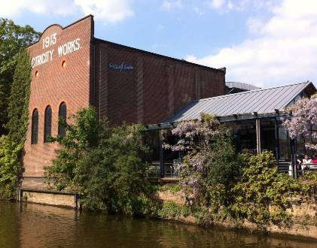
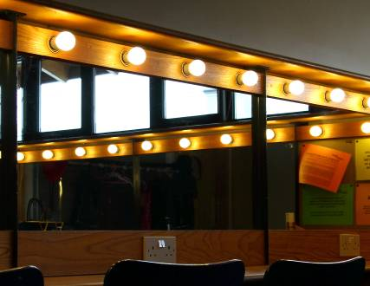
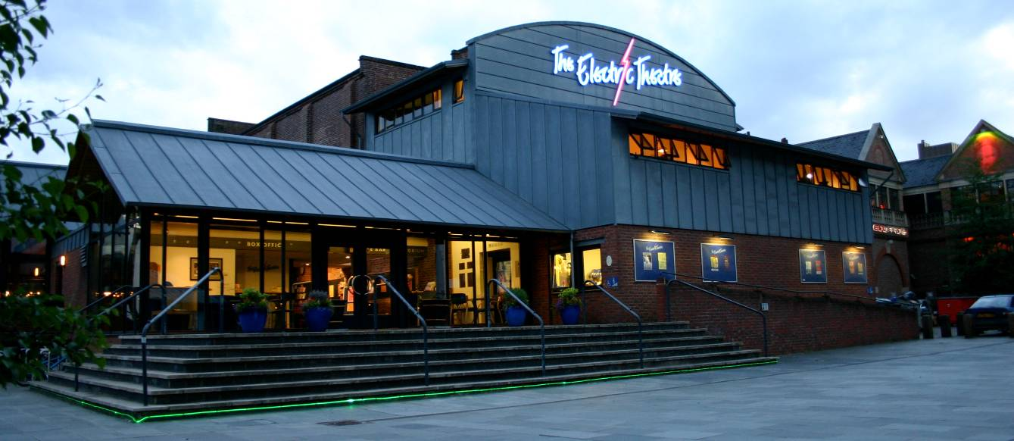
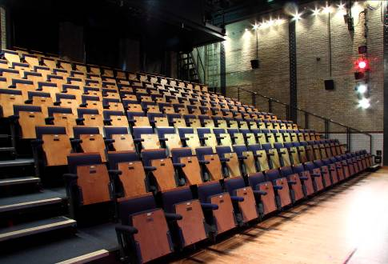
Welcome to
The Electric Theatre (Guildford) Ltd.

Here you’ll find all the basic information about the Theatre, as well as the facilities and equipment that are available for hire. If you’d like more specific information you can contact us using the following details:

General Manager 01483 501 200
Liz.woodall@electric.theatre

Administration 01483 501 200
Jenny.pegman@electric.theatre

Marketing and Box Office 01483 501 200
Post vacant

Development 01483 501 200
George.longland@electric.theatre

Technical 01483 501 200
Darren.carrig@electric.theatre
Howard.craggs@electric.theatre

Café Bar / Front of House 01483 501 200
Nathan.rogers@electric.theatre

General Box Office 01483 501 200

Website www.electric.theatre

Facilities for Hire

Auditorium

Formats / capacities
Theatre style 180 seats
(210 seats with the orchestra pit seating made available)
Standing 250
Cabaret style 100

For other Auditorium formats / capacities, please contact the Technical Team.

Hire Fees (the current rate of VAT will be added to all hire fees) January to March 2017
 | Amateur / Non Commercial Rate | Commercial Rate
Weekly rate | £2020 | £3315
Daily rate | £540 | £1221
Hourly rate | £45 (minimum 4 hours) | £272
Please note: A commission is payable on all ticket sales taken through The Electric Theatre Box Office (see ‘Recharges / Costs’ for more information). For all performances sold through the Theatre’s Box Office, four house seats will be held off sale.

Weekly rate includes Sunday 10:00-23:00
Monday 10:00 – 2300
Tuesday to Friday 17:30 – 2300
Saturday 13:00 – 23:00

Use of the Auditorium during the day on Tuesday to Friday is subject to availability and an additional charge will be levied.

Daily rate One day from 10:00 – 23:00
Hourly rate Per hour from 10:00 – 23:00 (subject to availability)

Included in the Amateur Rates:
- Duty Technician (to supervise the production, not to operate sound / LX or stage manage)
- Duty Manager (for performances)
- Ushers (for performances)
- Box Office ticket sales (online, in person, by post and by phone)
- Use of the Theatre’s drapes, rostra, lighting and sound equipment
- Use of two Dressing Rooms (from 1400 on a Monday for a week long hire)

Included in the Commercial Rate:
- All Technicians required to get in, rig, run and operate the performance/s
- Duty Manager (for performances)
- Ushers (for performances)
- Box Office ticket sales (online, in person, by post and by phone)
- Use of the Theatre’s drapes, rostra, lighting and sound equipment
- Use of two Dressing Rooms (from 1400 on a Monday for a week long hire)

The Farley Room can be used for additional dressing room space (subject to availability). There is a separate hire fee for the use of this area and it must be cleared following every performance.

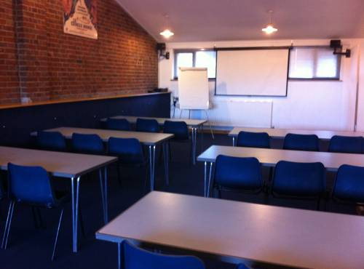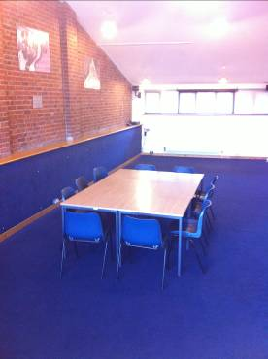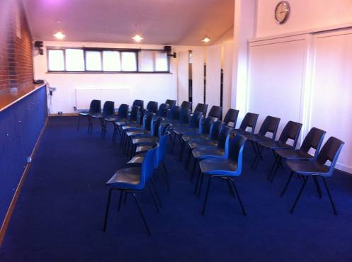

Farley Room

Formats / capacities
Theatre style 30 side on
Theatre style 50 end on
Classroom style 24
Around tables 24
Horseshoe 15

Please note: the Farley Room is only accessible by stairs.

Hire Fees (the current rate of VAT will be added to all hire fees) to December 2017
 | Amateur / Non Commercial Rate | Commercial Rate
Hourly rate | £27 | POA

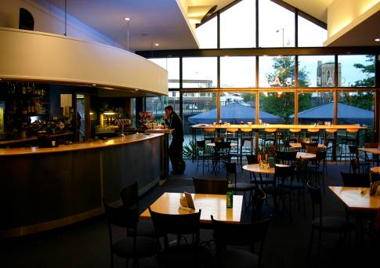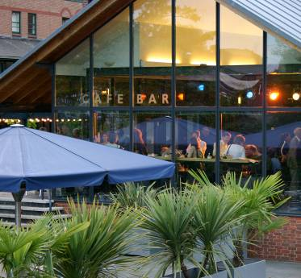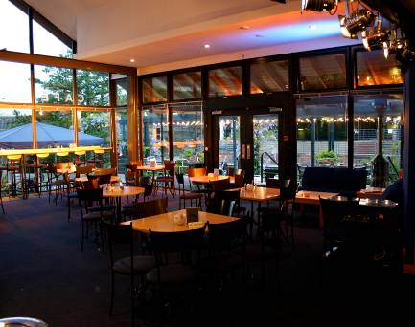

Café Bar

Formats / capacities
Theatre style 80, plus 10 standing
Café style 45, plus 10 standing

Hire Fees (the current rate of VAT will be added to all hire fees) to December 2017
Hourly rate | £36
Exclusive use | POA

Recharges / Costs
Please note: the current rate of VAT will be added to all costs included in this pack, including hire fees
Deposits
Deposit for hire fees  (To be paid in advance of the booking) | £250 + VAT for week long hires  £100 + VAT for day long hires
Box Office
Commission on ticket sales  (This applies to all events where tickets are sold through the Theatre’s Box Office) | 13% on all sales
Ticket printing fee  (This applies to events where tickets are printed for sale at external box offices / through local groups / agency tickets etc.) | £0.12 per ticket
PRS
Applies to all performances with music (unless confirmation is given by the hirer that the music being performed is not subject to PRS) | From 3% of gross Box Office income (depending on genre)
Insurance
Public Liability Insurance (£5million)  (NB if proof of £5million PL insurance is not provided in advance of the hire, the amount opposite will be added to the event settlement) | £205 for week long hires  £67 for day long hires
Marketing
The Electric Theatre Season Brochure inclusion: One third of a page  Two thirds of a page  Full page | £65  £125  £220
Technical
The Theatre’s up to date Tech Spec is available online at www.electrictheatre.co.uk
Smoke / haze machine (including 1 x 2.5litre bottle of fluid) | £33 for week long hires  £17 for day long hires
Projector  Christie DHD 951Q 8500LM HD projector with lens 0.8-1.0 or 1.6-2.4 | £300 per week  £100 per day
Projector  Epson EMP7900 XGA 4000LM projector with lens 1:1.35 | £200 per week  £75 per day
22ft x 17ft rear projection screen  Fixed position bar 12 | £150 per week  £75 per day
12ft x 9ft rear projection screen | £100 per week  £50 per day
8ft x 6ft front projection screen | £80 per week  £40 per day
Extra hours / part hours (outside of contracted hours, including run overs) | £106 without notice  £71 with prior notice
Technical staff (including sound / LX operators) | £16 per hour
Pit installation / removal | £96
Robe Robin DLS Lights | £108 per week per light  £54 per day per light
Other technical equipment/services may be available. Please contact the Technical Team for a specific quote
Catering
Bar tab (on agreement) | As taken
Other
Extra car parking (if available) | £16 per space
Clean up fee | From £280
Security – per person, per hour, minimum 4 hour call | £18 per hour
Photocopying (black and white only) | £0.13 per A4 sheet
Other Information

Catering
The Electric Theatre Café Bar is open to the public from 1000 – 1700 on Saturday, and from 4:30until after the performance on a show night. The Café Bar serves a range of hot, alcohol and soft drinks as well as snacks.

Marketing
The marketing of your event at The Electric Theatre is your responsibility; however, our Marketing Team is able to provide support and advice if you need it.

Box Office
The Box Office will contact you directly to confirm your event details. These will include dates / times, ticket prices and concessions, format and general sales information.

Car Parking
Included in your hire are three car parking spaces by the Theatre’s Stage Door. When using these spaces a valid Electric Theatre Parking Permit must be displayed. These are available from a member of Theatre staff at the start of your hire. Please be aware that Parking Enforcement Officers do patrol this area, and you are responsible for ensuring that your vehicles display a valid permit.

As a rule, no other car parking is available at the Theatre, other than for disabled patrons. However if you do require extra then please check with a member of Theatre staff in advance as on occasion it may be possible to arrange. Any extra parking will be recharged.

The nearest pay and display car park is Bedford Road, by the Odeon Cinema.

General
Wi-Fi is available in most areas of The Electric Theatre. This is free of charge.

We hope you enjoy your visit to The Electric Theatre and if you require any further information please do not hesitate to contact us.

