//FOR IMMEDIATE RELEASE//
ACM Winter Festival – Snippets of the Sounds of the Next Generation!
Next week is the kick-off week of the inaugural ACM Winter Festival at the Electric Theatre in Guildford featuring students from the second-year on the Creative Artist Bachelor course. In addition, there will be some special headline performances from more established artists and Academy of Contemporary Music alumni, followed by a month of a series of more free gigs and showcases in The Star (Guildford), Stane St. Syndicate (Clapham) and Belushi’s (Hammersmith).

This is a chance to explore new original music and maybe discover your new favourite artists and bands.

Expect original music from the next generation, concerts across genres and styles community festival days and charity events raising money and awareness for homelessness and mental health in this exciting string of events organised by the Technical Services and Business and Innovation students at ACM.

“You can expect to see an energetic rock line-up or moody electronica, check out the family friendly live lounge on Saturday afternoon and support homeless charities or explore soulful pop and lyrical singer/songwriters. Each event has a separate feel and theme, so there really is something for everyone.”
Chris Carney, ACM Tutor/Live Events Manager
WHO:
Acts playing, in alphabetical order:
Arthur Bean | Jessica Newson | Rosie Tavender
BeArte | Jordan Lee | Shywolf
Bethia Ward | Joseph Idalu | Sica
Biloxxi | Kissed and Crowned | Simple Fiction
Briggs | Laurie | Sophie Rhymes
China Bears | Lonely Ocean | Sycopax
Chinchilla | MARDHYS | Tara Flannagan
Conan Mac | Matthew Ross | Maisy Joan
Crossways | MIMI | Thomas Gerard
E L L I S I O N | Molly McKinna | Tia Jackson
Emily Stock | Molly Nicholson | Tom Breeze
Eva-Lina | Molly Ross | Tyrell Trey Payne
Harry Miller Band | Mountfield | Vikki McCormack
Heather Cameron-Hayes | Mysti | Waiting for Mallory
Hydrocele | Neon Islands | Who Saw the Light
Izzy Spyro | Rory Jones
HOW: Groups of students were tasked to put together themed nights of original music performances as part of their professional portfolio.
WHEN: 30th of October until the 30th of November 2017, with a kick-off week at the Electric Theatre.
WHERE: Guildford’s Electric Theatre and The Star, London’s Belushi’s and Stane St. Syndicate.

Body.
ACM recently acquired the Electric Theatre, taking the existing relationship to the next level and giving the students and staff an exceptional opportunity to engage with the local community. The other gigs as part of the festival period take place at the noted Guildford music pub The Star (an ongoing partner of ACM), London campus partners Belushi’s in Hammersmith and Stane St. Syndicate in Clapham.
“This is a fantastic opportunity for the students to gain real-life experiences and the local community to enjoy and explore new music, and maybe discover your new favourite band or artist before they are on everyone’s lips!”
Kaya Herstad-Carney - Senior Lecturer, Creative Artist and Artist Development

The first week of events at the Electric Theatre starts on Monday the 30th November with a Halloween themed night of solid songwriting and superb voices featuring sets from the breath-taking vocals of Izzy Spyro, Harry Miller Band and Molly Nicholson and fantastic songwriting from the mesmerising Molly Ross, Tom Breeze and China Bears. Plus, oodles of soulful delivery from Thomas Gerard and Tyrell Trey Payne.

Wednesday the 1st offers two themed events alongside each other and looks to promise a great night of music:

Main Stage Electric Theatre welcomes you to a Cosmic Winter themed alternative pop line up and many electronic influences, where you can expect sets from future pop diva Chinchilla, unique performance artist BeArte, hard hitting Drum & Bass from Sycopax, catchy songs from band Kissed and Crowned, creative and confident delivery from E L L I S I O N, beautiful melodies from Jessica Newson, experience and entertainment from Conan Mac and serious pop potential from Eva-Lina.

On the same night, the Foyer Space offers a theme of ‘Northern Lights’ with an opportunity for a more intimate experience with sets from confident and capable songwriters such as Emily Stock, Heather Cameron-Hayes and Jordan Lee, expert entertainers such as Tom Breeze and Briggs and standout indie acts Rosie Tavender, Sica and Neon Islands.

On Thursday 2nd November, if you are a fan of the more alternative, you’ll love the line-up at Electric! After returning from a European tour, Who Saw the Light once again grace the stage at the theatre with their energetic alternative post-rock. They are joined by the mysterious and cinematic Blanc Shine, the ever grungy Gryph and accomplished alumni band Lonely Ocean.

Friday the 3rd November in the Electric Foyer brings a busy of female-lead line ups with fantastic vocalists, strong songwriting and a Winter Wonderland theme. This is your perfect back drop for the beginning of the weekend, with sets from Tori Smith, Lauren Nicole, Red Book, Alice Frances, Chloe Diana, Phillipa Tsang, Deborah Abraham, Boglarka and Becky Barnett.

In the main space will a be different angle of Bonfire Indie, featuring red hot sets from the talented Sophie Rhymes, the compelling Crossways, familiarly fabulous Simple Fiction, harmonically haunting Mountfield and catchy, energetic sets from Waiting for Mallory, Biloxxi and Hydrocele.

Saturday 4th November: The final night of the week is in aid of homelessness, but although the event has a bleak theme; the show will rather celebrate happiness and wellbeing, with sets from some of the most accomplished artists of the Creative Artist Course: MIMI, MARDHYS, Bethia Ward, Tara Flannagan, Tia Jackson, Tori, Rory Jones and Vikki McCormack.

Also on the 4th November a darkly themed event is happening at Stane St. Syndicate in Clapham, London. Prepare to get your feet a-tapping and your brains a-thinking for this Day of the Dead themed event featuring nu-folk blues artist, Shywolf, charmingly time-warped Maisy Joan, groovy Joseph Idalu, jazzy and poppy Laurie, mystical chick Mysti, delicate and delightful Molly McKinna and super talented atmospheric hip hop artist Arthur Bean.

Other events in future, more info to follow:

Tuesday 14th November at - The Star Backroom, Guildford
Wednesday 15th November - Demo 1 Theatre, ACM Guildford
Thursday 16th November - Belushi's, Hammersmith, London
Saturday 18th November - Stane St. Syndicate, Clapham, London
Tuesday 21st November - The Star Backroom, Guildford

Electric Theatre website: https://electric.theatre/

Boilerplate

ACM aims to incubate potential and talent, supporting the personalised development needs of the students to facilitate a structured path from education to employment.
They provide a safe and supported space where creative talent and imagination can flourish in a caring environment. Barriers to learning are identified through a holistic and person-centred approach to unlock the potential of the individual, enabling personal growth through professional and academic development. A core aim is for the students to enjoy lifelong sustainable careers underpinned by applied learning and a specialist, cutting-edge curriculum.
Therefore, the vision is to not only be the leader in applied, industry-connected, creative arts education but to also be the leader in care and support for mental health and other traditional barriers to learning, thereby driving up the standards expected within higher and further education.

Mission
To provide an immersive student experience, with a curriculum which is connected to the industry in real-time, based on a learning by doing ethos. The core aim is to build confidence and self-awareness, providing students with the skills necessary to recognise and take opportunities.
Ultimately the mission is to enable students to fulfil their potential and enjoy a sustainable career within the creative arts industry.

ACM Values Are:
Inclusivity
To empower individuals from diverse backgrounds, to maintain accessibility, and provide an inclusive organisational culture.
Supportive environments
To provide environments that support personal and professional development through a holistic approach and bring the benefits of the creative arts to the wider community.
Agility and innovation
To provide an inspiring organisational culture that embraces innovation through openness, flexibility, creativity and self-evaluation.
Connectivity
To recognise the benefits of working closely with industry and others, to embrace new technologies, and to provide meaningful opportunities, in order to enhance learning.
Professional and academically strong standards
To provide state of the art professional environments, to inspire determination and enthusiasm, and ensure high professional and academic standards.

Links:
http://Acm.ac.uk
https://electric.theatre

Social Media links and Student contacts available upon request for all above events!

Tutor contacts:

Chris Carney – Live Event Management tutor, core module on Technical Services and Business and Innovation curses. ccarney@acm.ac.uk Tel: 07743432129

Kaya Herstad-Carney – Senior Lecturer Stagecraft & Presentation and Artist Development. kaya@acm.ac.uk Tel: 07876286283

MEDIA

Higher resolution pictures attached or high res requested.

Harry Miller Band - the 30th October, Electric Theatre
http://jbhopgood.wixsite.com/theharrymillerband
Photo John Seaman
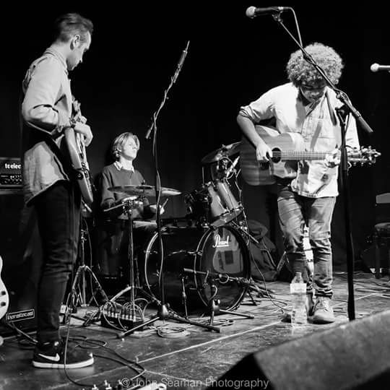

Eva-Lina - Wednesday 1st November, Electric Theatre
https://www.eva-lina.com/
Photo: Rob Blackham Images
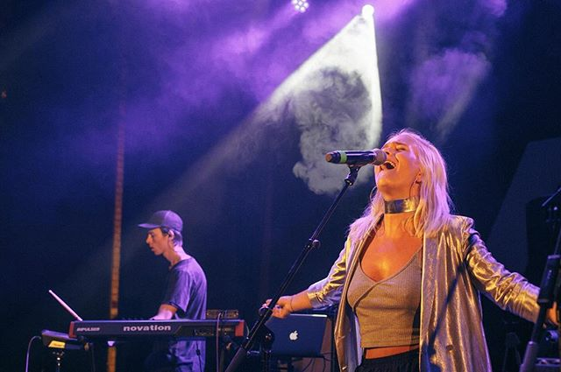

Who Saw The Light - 2nd November, Electric Theatre
https://whosawthelight.bandcamp.com/releases
Photo: Band’s Own
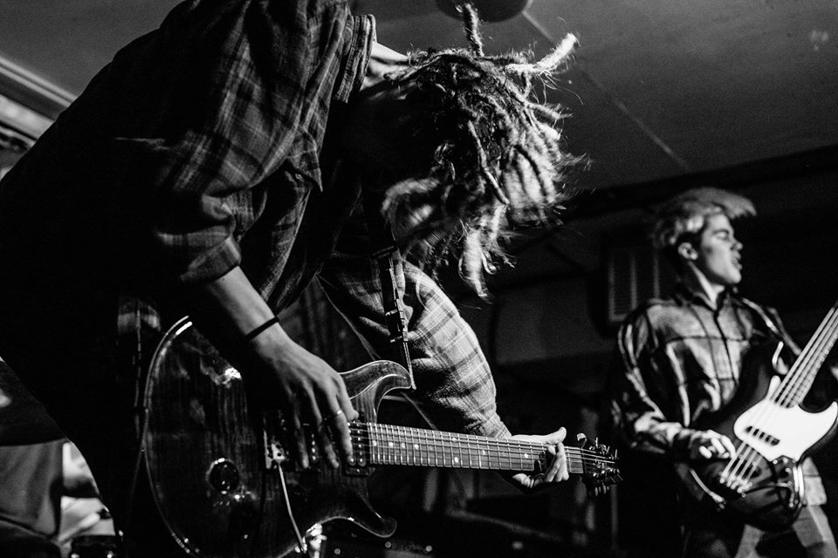

Hydrocele - Friday the 3rd November, Electric Theatre
https://www.hydrocele.co.uk
Photo: Band Official
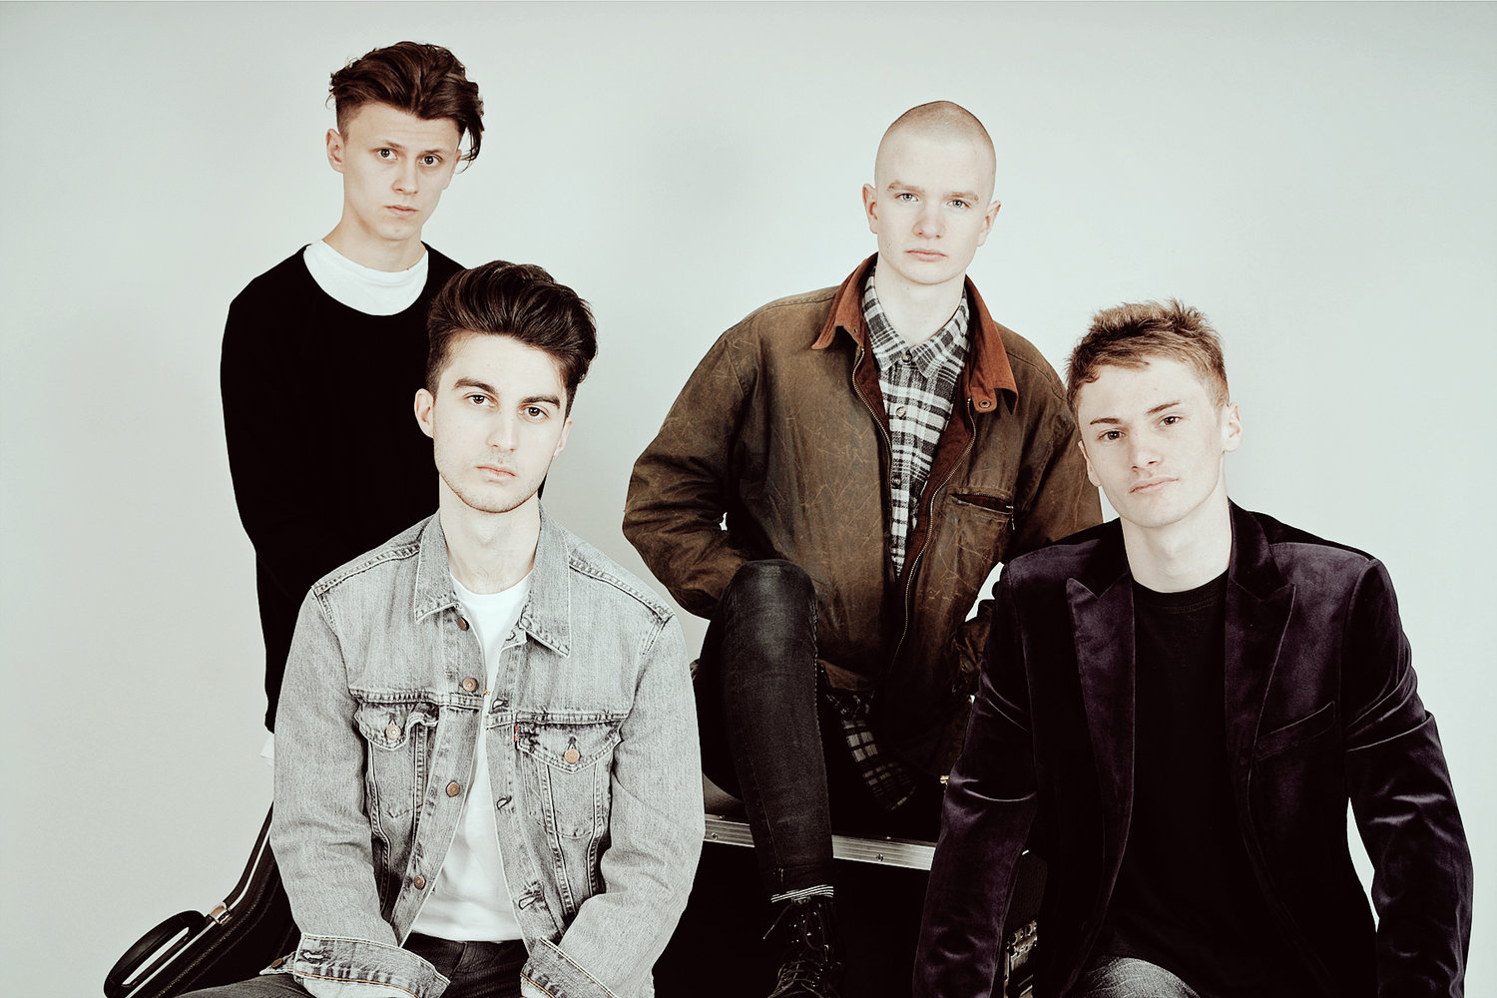
Mardhys - the 4rd November, Electric Theatre
https://www.mardhys.co.uk/
Photo: Rob Blackham Images
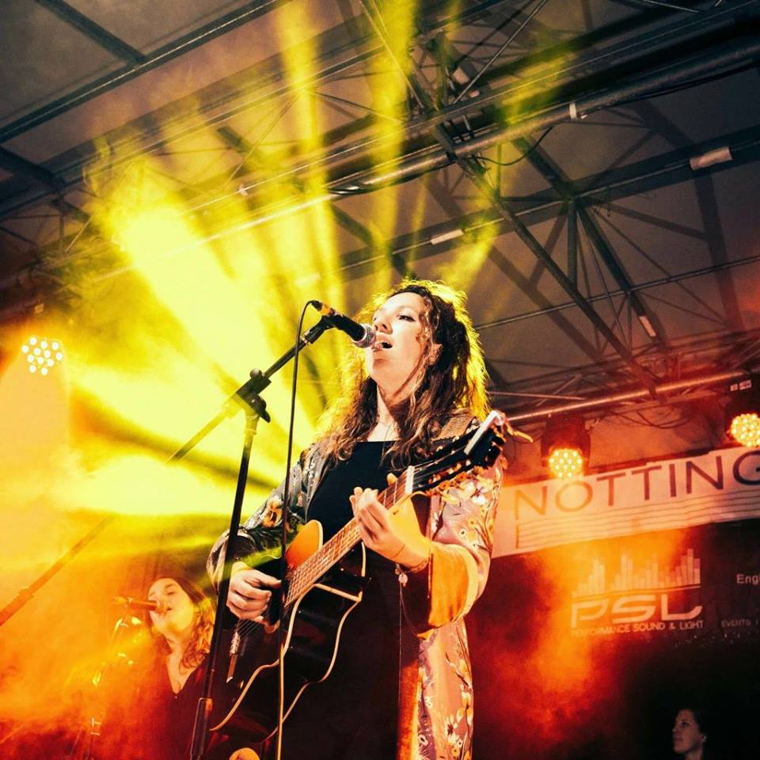

Molly McKinna - the 4rd November, Stane Street Syndicate
https://mollymckinnamusic.wixsite.com
Photo: Artist’s Official
